Data Analytics ISE Activity: Datathon

Project Title: Customer Shopping Behavior Analysis
Name: Mayuri Gaikwad
Date: 6th April 2026

1. Project Overview
This project focuses on analyzing customer shopping behavior using data analysis techniques in Python. The dataset contains customer demographics, purchase details, and shopping patterns. The goal is to clean, preprocess, and transform the data to extract meaningful insights that can help businesses understand customer preferences and improve decision-making.

2. Dataset Summary
- Rows: 3,900
- Columns: 18
- Key Features: - Customer demographics (Age, Gender, Location, Subscription Status)
- Purchase details (Item Purchased, Category, Purchase Amount, Season, Size, Color)
- Shopping behavior (Discount Applied, Promo Code Used, Previous Purchases, Frequency of Purchases, Review Rating, Shipping Type) - Missing Data: 37 values in Review Rating column
3. Objectives
- Analyze customer purchasing behavior
- Understand customer segmentation based on age
- Study purchase frequency patterns
- Prepare data for further analysis or machine learning
- Store processed data for database use
4. Dataset Description
The dataset includes customer-related information such as:
- Age – Customer age
- Category – Product category
- Purchase Amount (USD) – Amount spent
- Frequency of Purchases – Shopping frequency
- Review Rating – Customer rating
- Discount Applied / Promo Code Used – Promotional activity

5. Data Preprocessing
We began with data preparation and cleaning in Python:
- Data Loading: Imported the dataset using pandas.
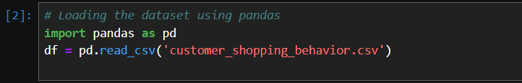
B. Data Overview
● Initial Exploration: Used df.info() to check structure and .describe() for summary statistics.
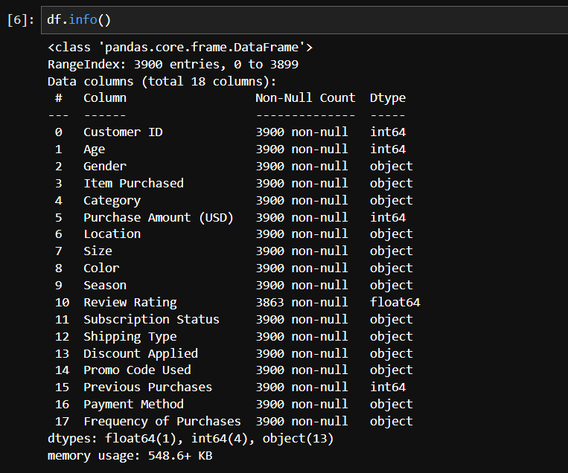
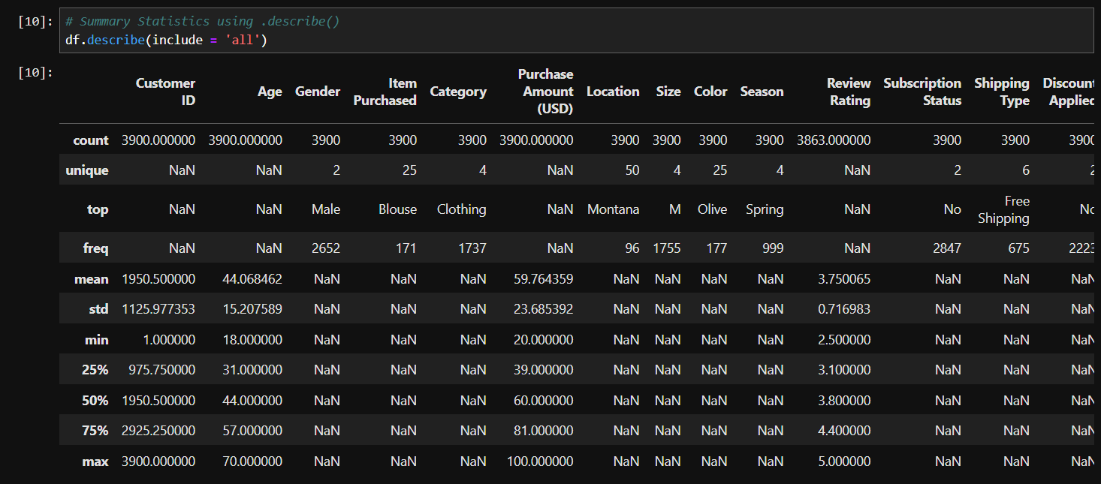
- Handling Missing Values
Checked for null values and imputed missing values in the Review Rating column using the median rating of each product category.
- Column Renaming
- Improves readability
- Makes column names consistent

6. Feature Engineering
- Age Group Creation:- Customers are divided into:
  - Young Adult
  - Adult
  - Middle-aged
  - Senior
This helps in customer segmentation
- Purchase Frequency Conversion
- Converts categorical frequency into numeric values (days)
- Makes it usable for analysis & ML
7. Exploratory Data Analysis (EDA)
Example 1: Age Group Distribution (Bar Chart)
Explanation:
- Shows how customers are distributed across age groups
- Helps identify dominant customer segment
Observation:
Most customers belong to the Adult and Middle-aged group, indicating higher purchasing activity in these segments.

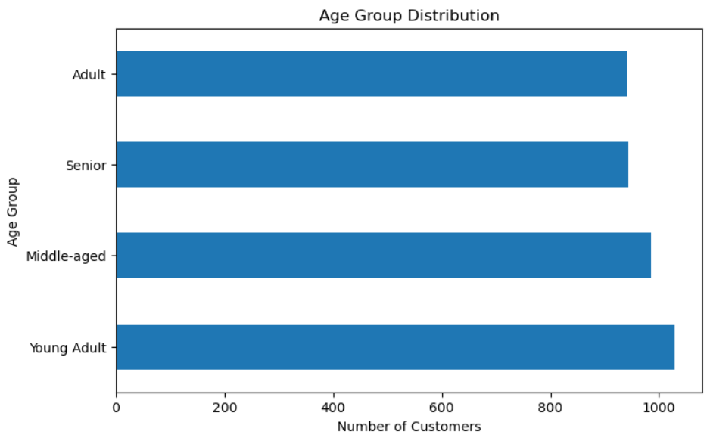

Example 2: Purchase Amount by Category
Explanation:
- Compares spending across product categories
Observation:
Certain categories(clothing) generate higher revenue, indicating customer preference and demand.
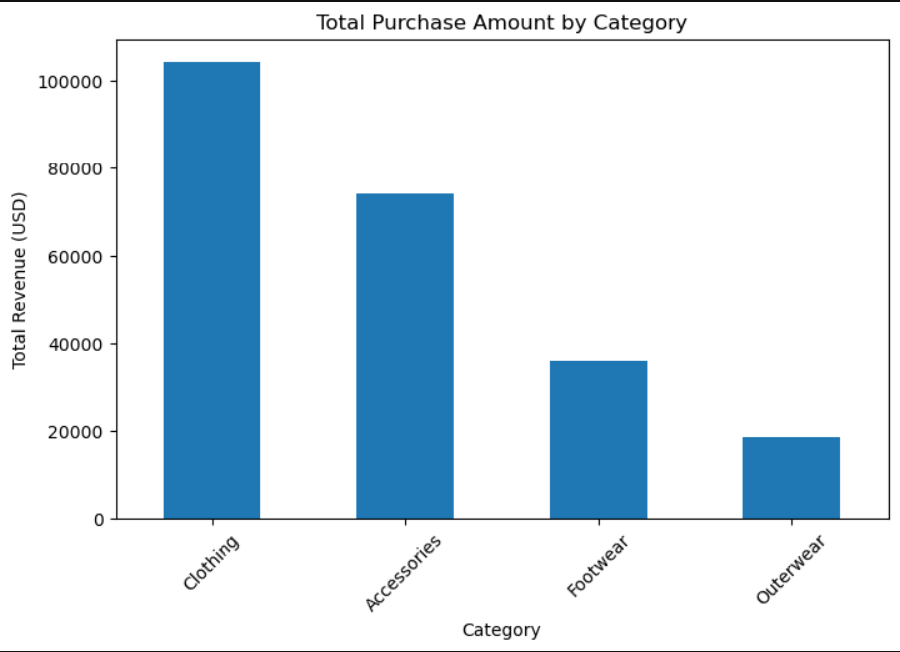

8. Database Integration
Performed structured analysis in MYSQL to answer key business questions:
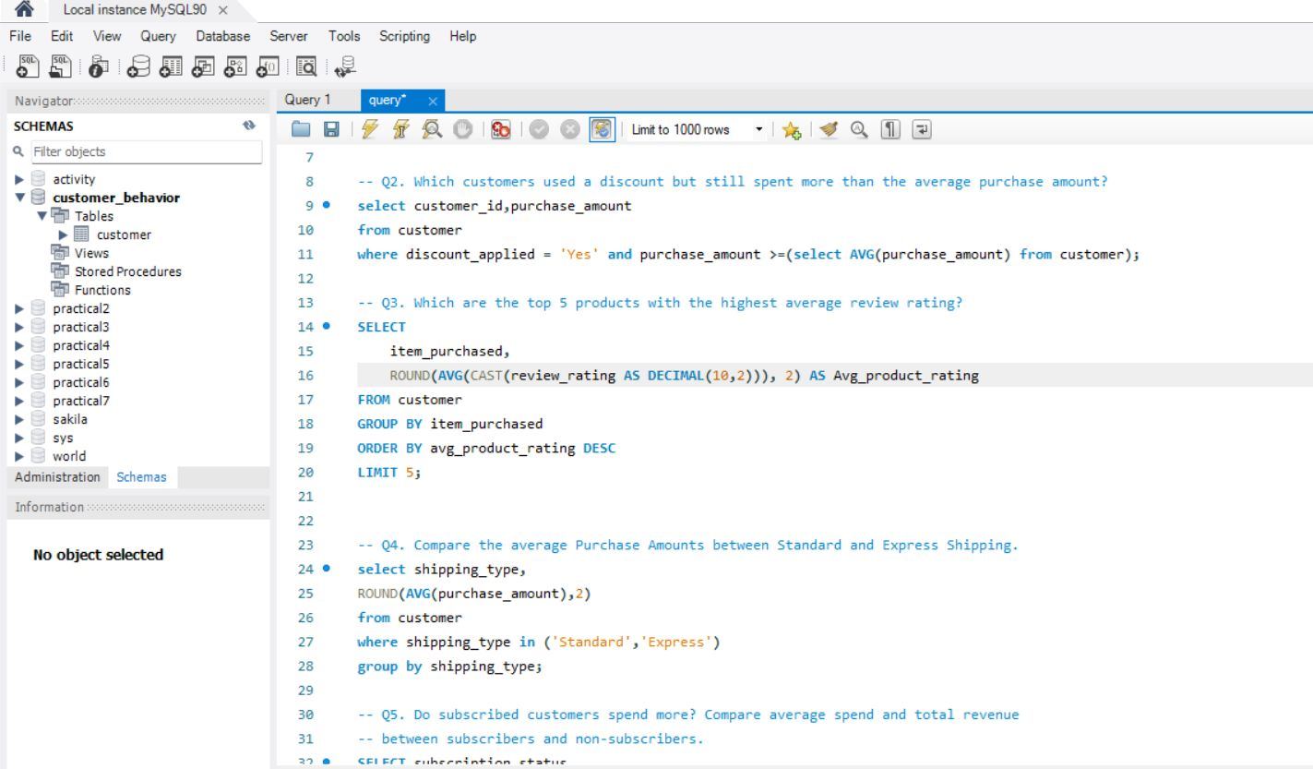
9. Dashboard in Power BI
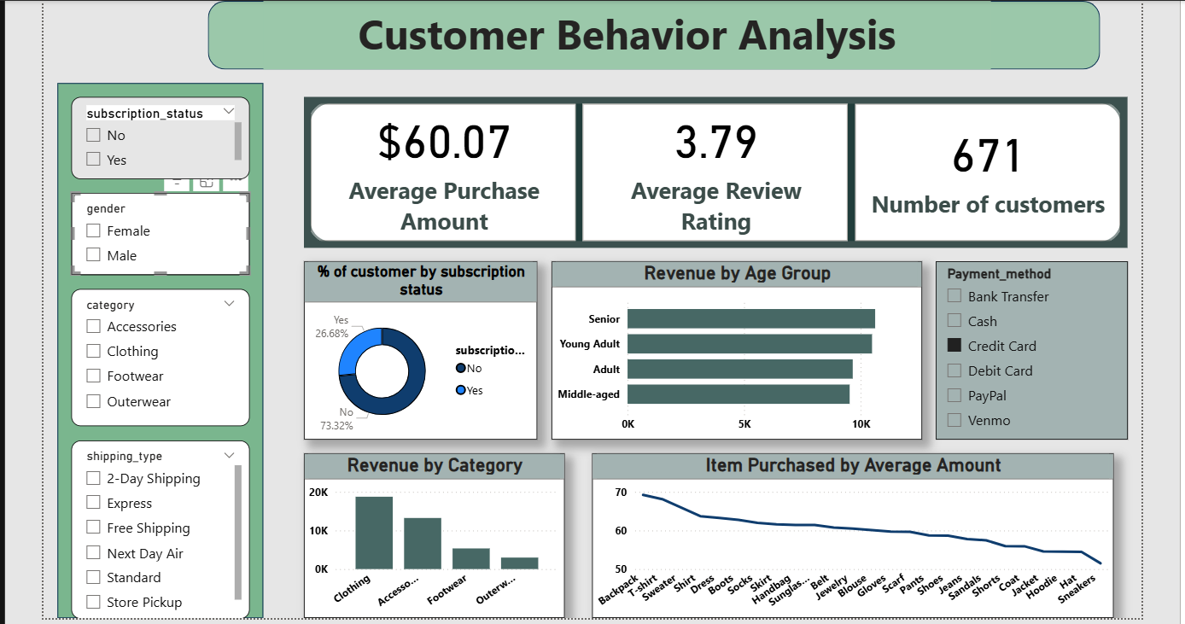

10. Conclusion
The project successfully preprocesses and structures customer shopping data. By transforming raw data into meaningful formats, businesses can better understand customer behavior, optimize marketing strategies, and improve decision-making.

